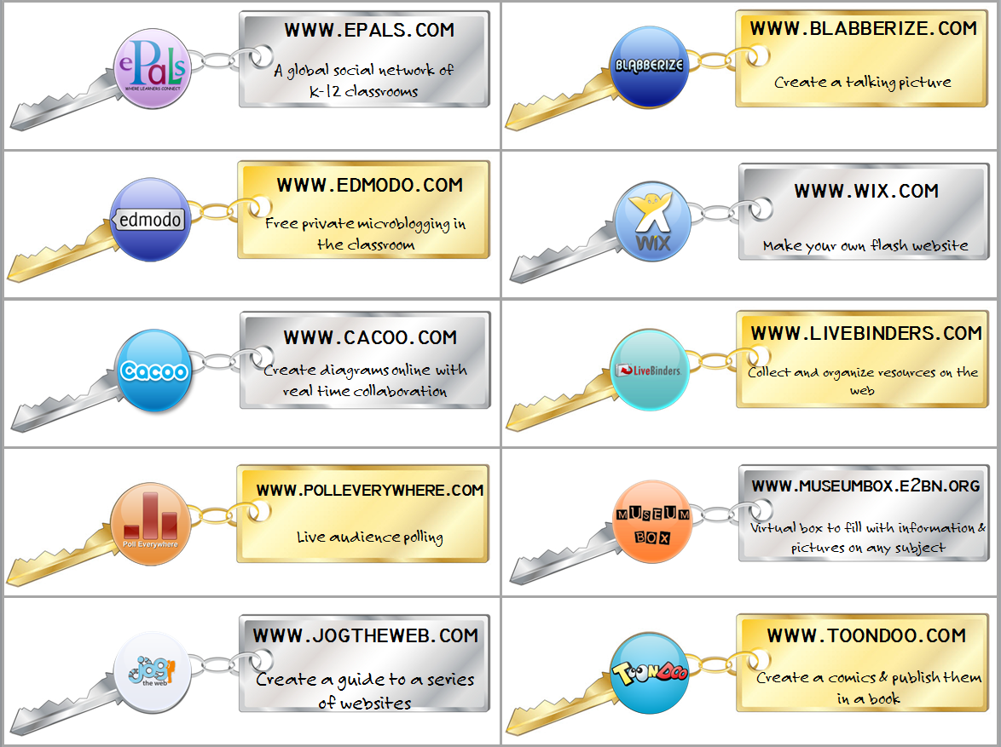
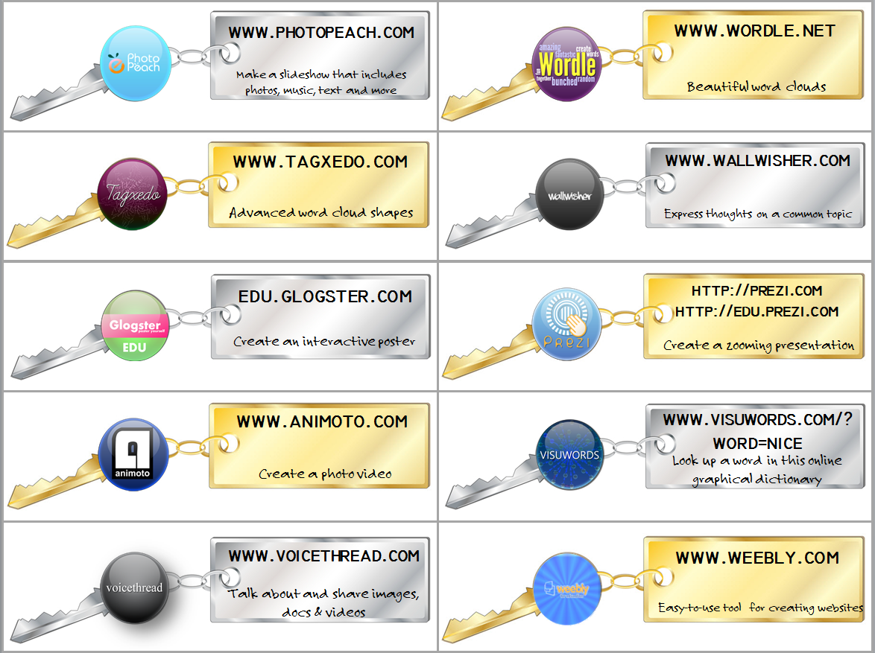

URL Font: Technic
Download HERE

Description: Font Felt Tip Roman
Download HERE

